**SQL Workshop Setup Instructions**

1. Go to <https://www.gearhost.com/> and register for a free account
   1. You will get an email to verify your email address from GearHost, follow its instructions
   2. Skip the tour
2. Click on the Database button on the left and then select the “Create Database” button

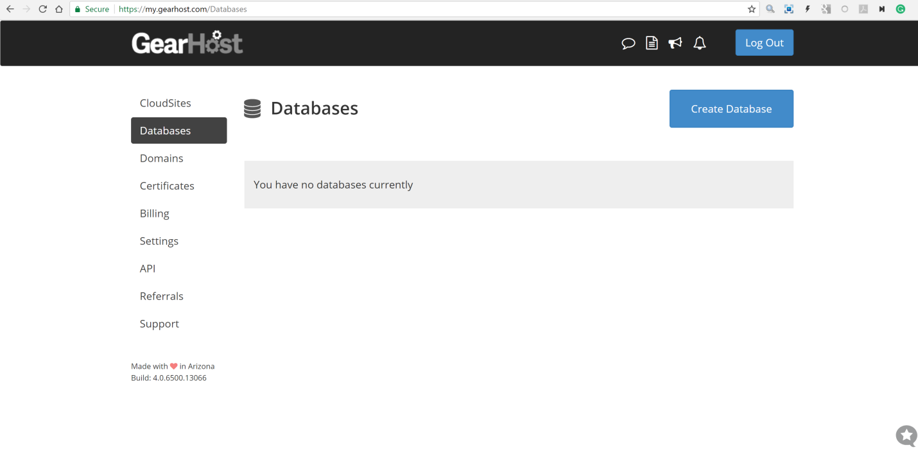

1. Choose the free option…it should be the first on the list called with the name “MySQL”.
   1. Name your database something easy to remember/use
   2. I will choose BeachBear
   3. Scroll down to the bottom of the page and select Create Empty Database

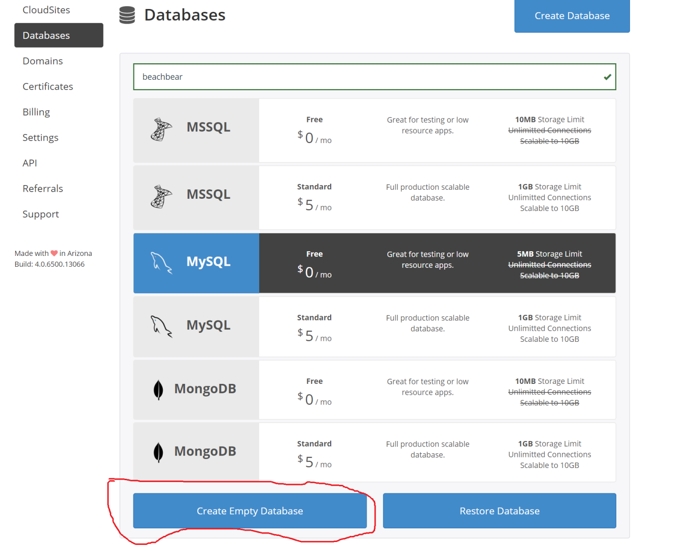

1. This will bring up a new page

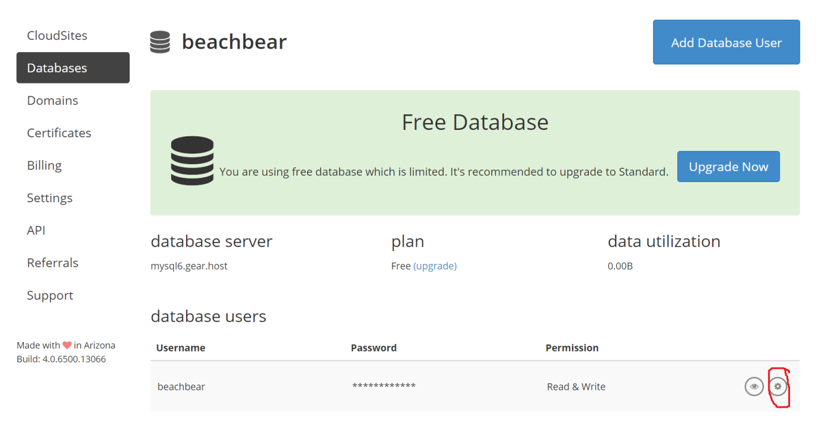

* 1. Select the button circled to change your password to something easy to use/remember

1. Things you will need from this page above
   1. Database server: mysql6.gear.host
   2. Username: beachbear
   3. Password
2. Download and install MySQLWorkBench
   1. The first page you should see when you open is:

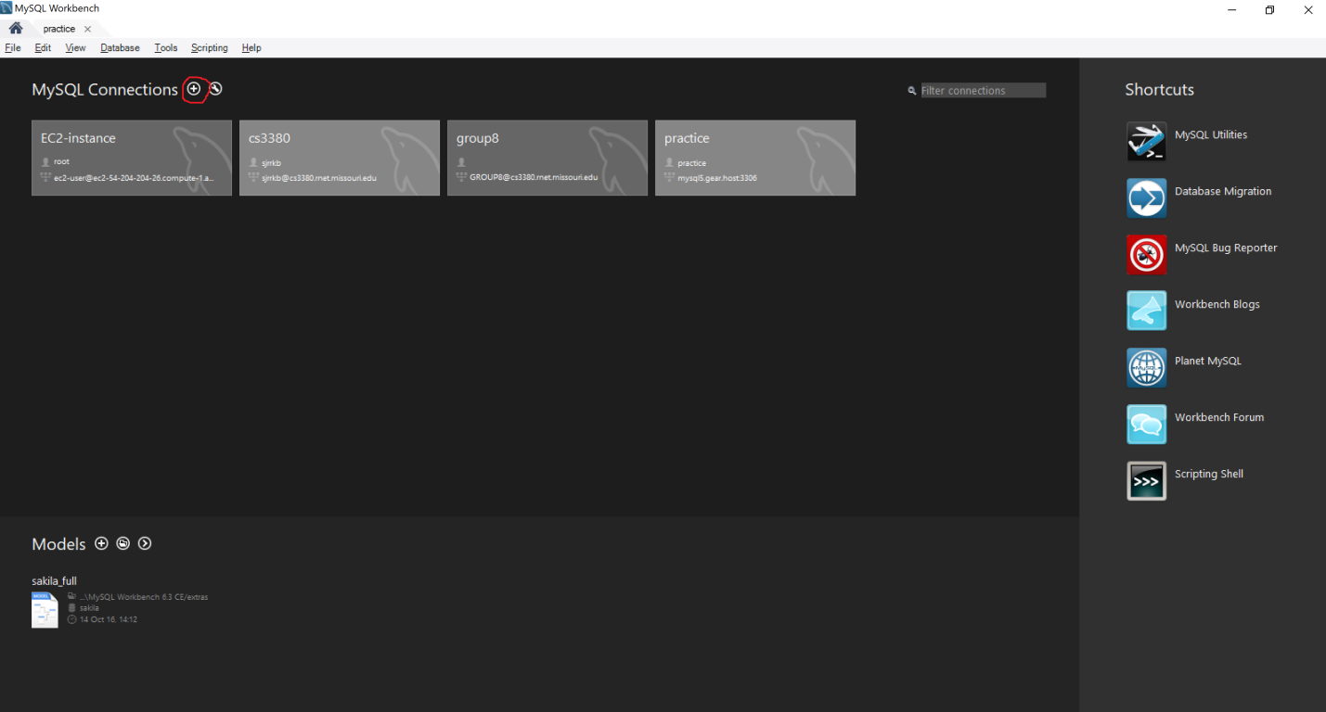

* 1. Note you will not have any connections so this should be blank
  2. Select the button circled in red to create a new connection
     1. You will need the information from step 5 for this part

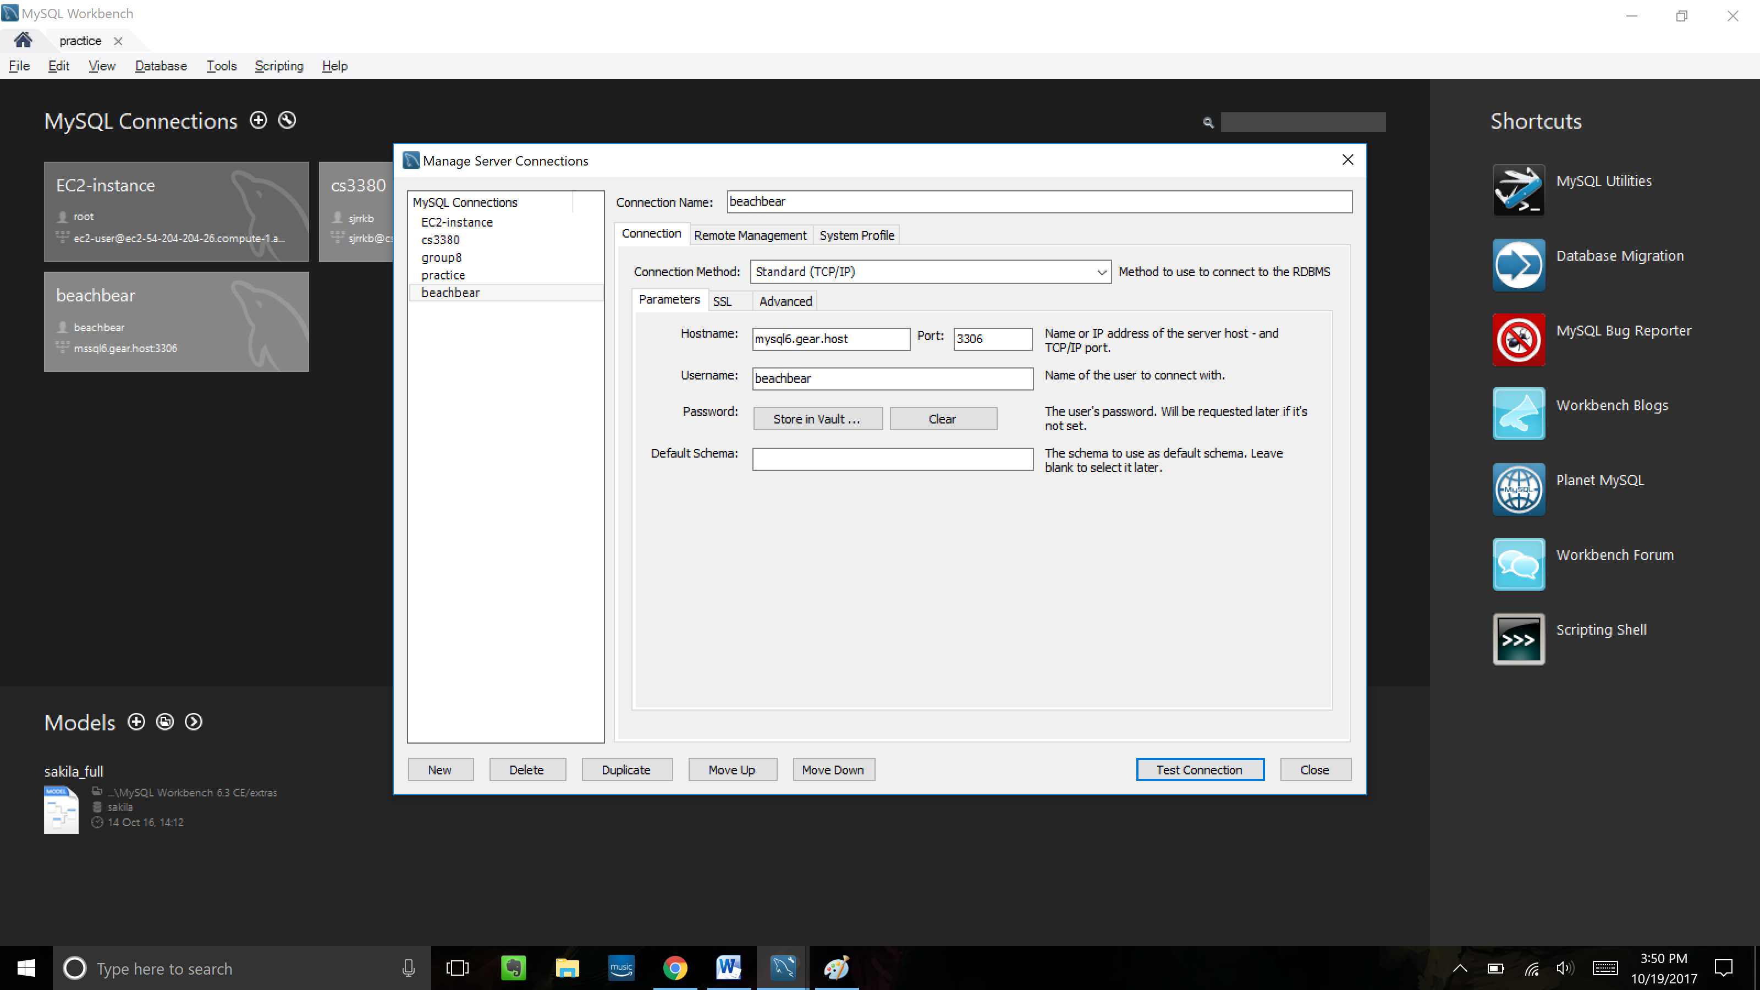

1. Now you need to enter the following information
   1. Connection Name
      1. Put whatever you want here
   2. Hostname
      1. This is your database server from step 5
   3. Port
      1. Keep at 3306
   4. Username
      1. This is your username from Step 5
   5. To enter password
      1. click “Store in Vault”
2. You should see the following picture appear after you click store in vault

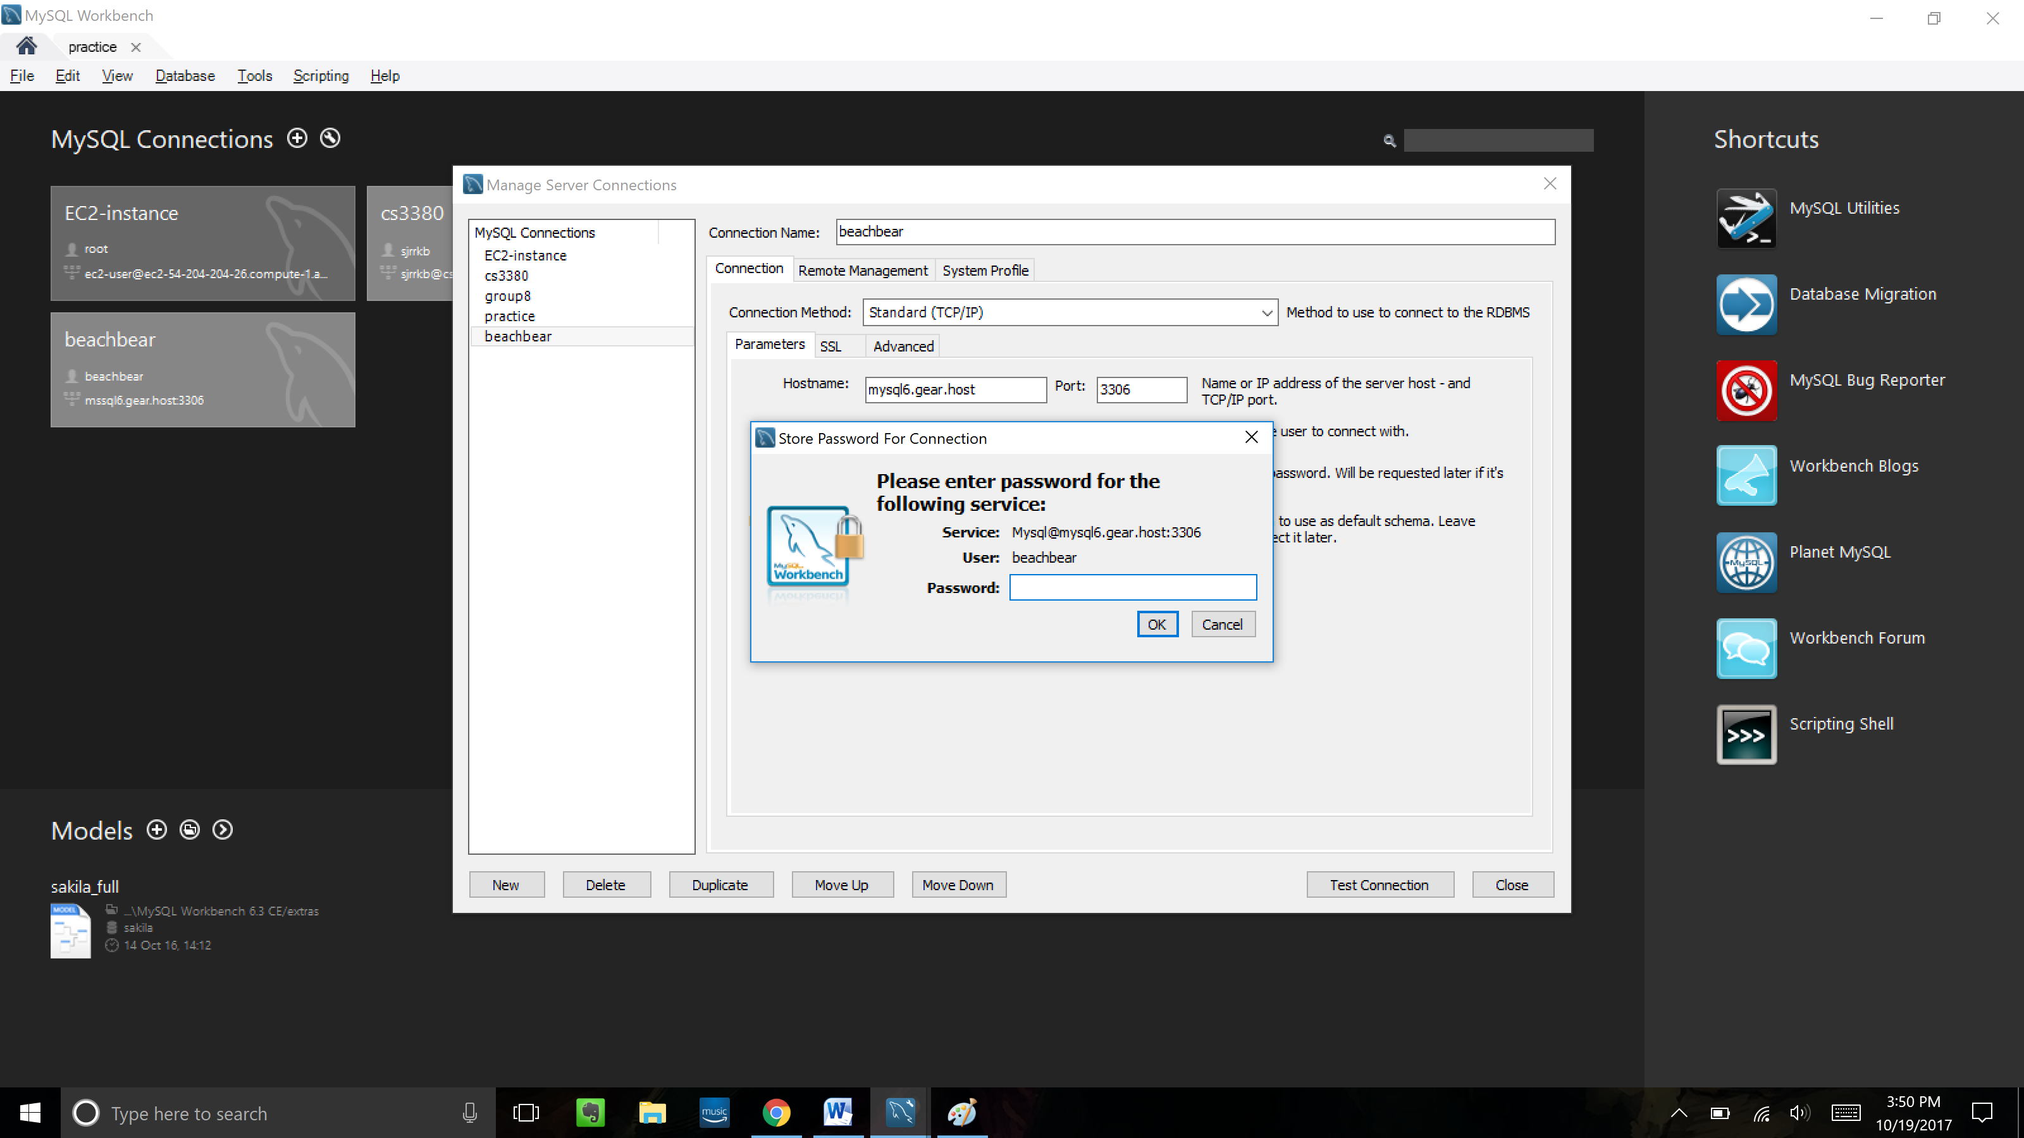

* 1. Enter your password into the password field and press ok

1. Hit the “test connection” button to see if you entered valid inputs for steps 7 & 8
2. You should see the following message

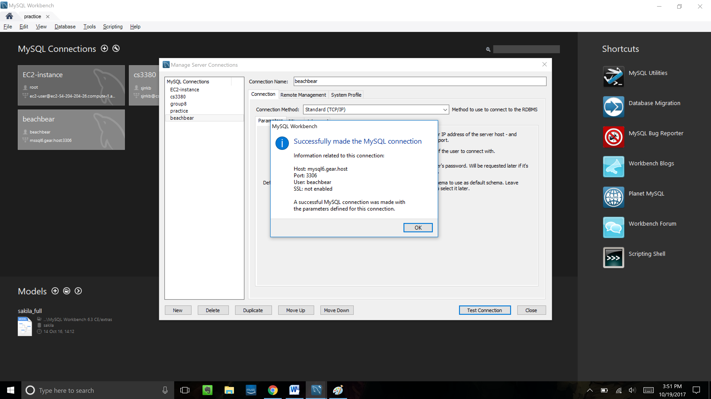

* 1. Now hit Ok then close
  2. Double click on your connection and you should see this screen

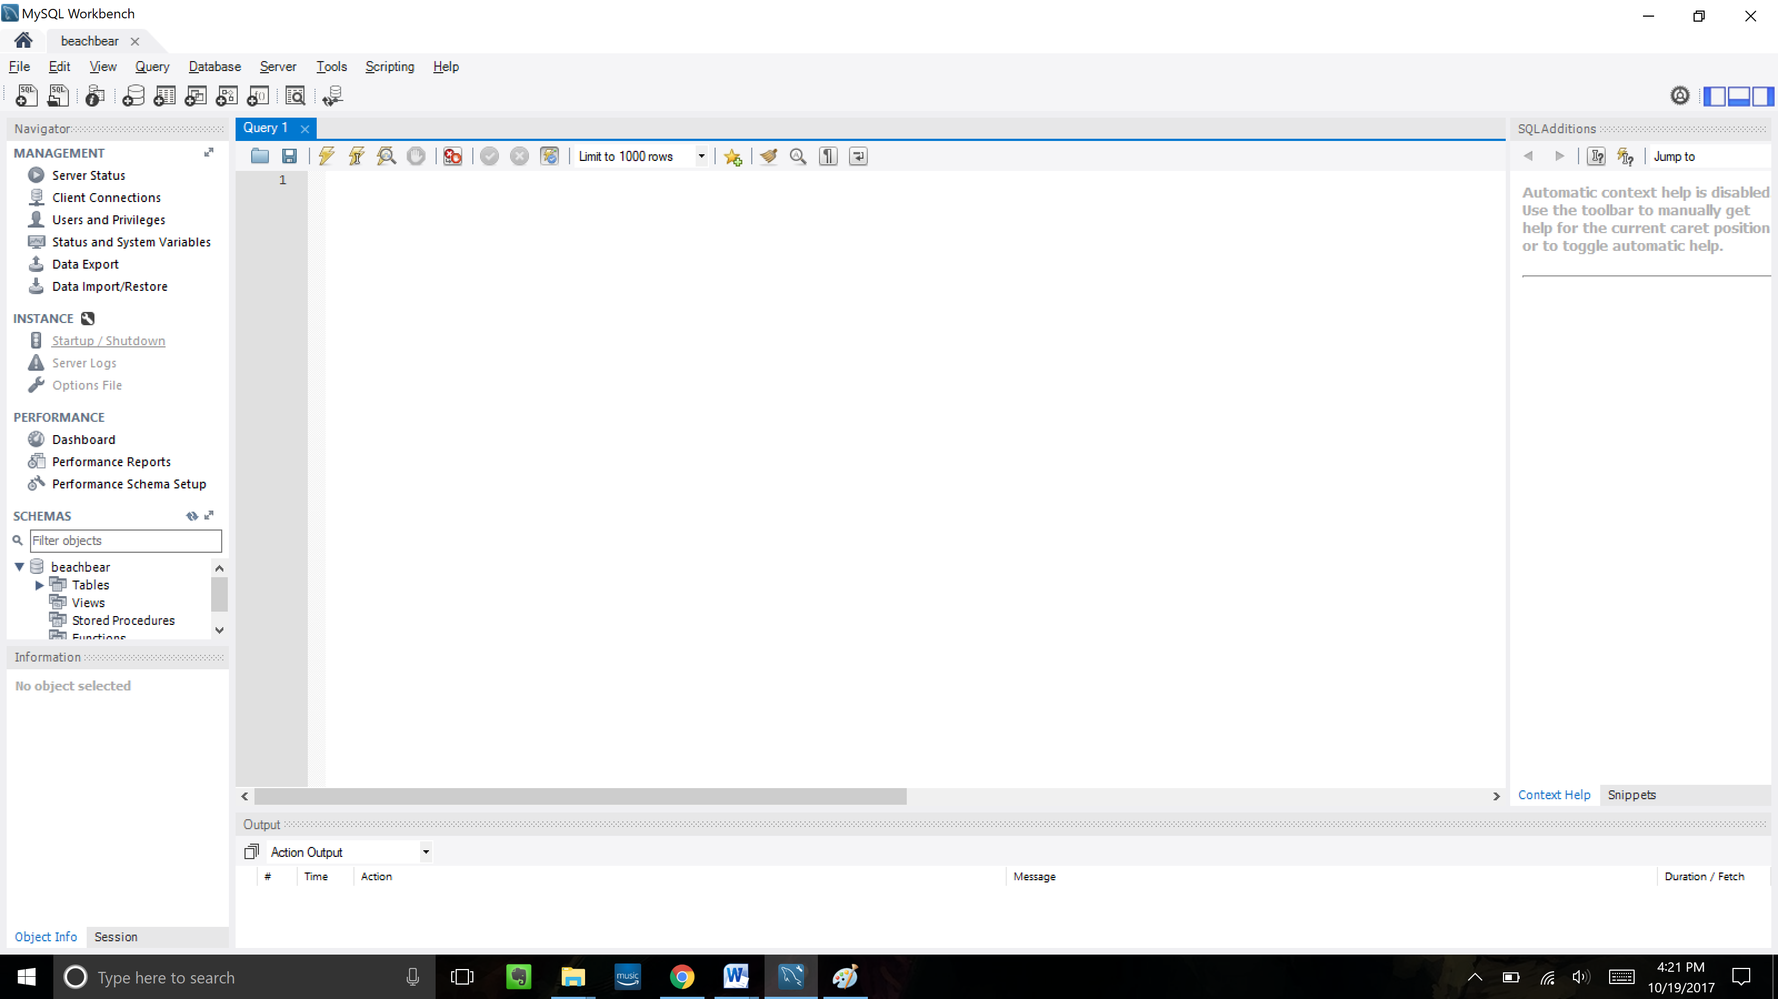

1. Now go to

<https://github.com/sjrrkb/SQL-workshop-files>

* 1. Click “Clone or Download” and select “Download Zip”
  2. Go to your downloads folder and unzip the file to any destination that you are easily able to find
     1. I unzipped it to my desktop

1. Now we are going to bring the .sql file into MySQLWorkBench which is pretty simple
   1. Hit the button circled in red to open your .sql file

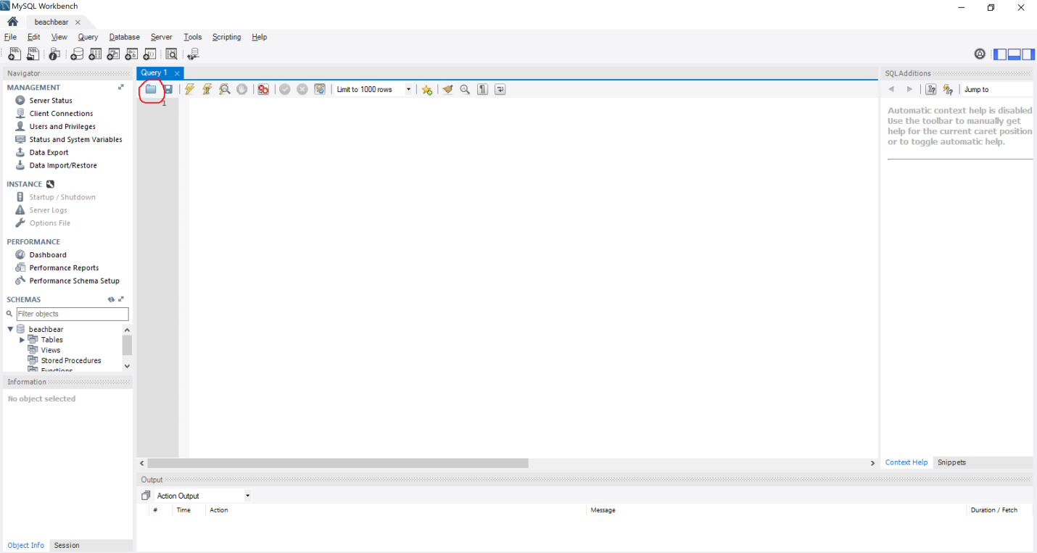

* 1. Now once you load your .sql file in you should see the following screen

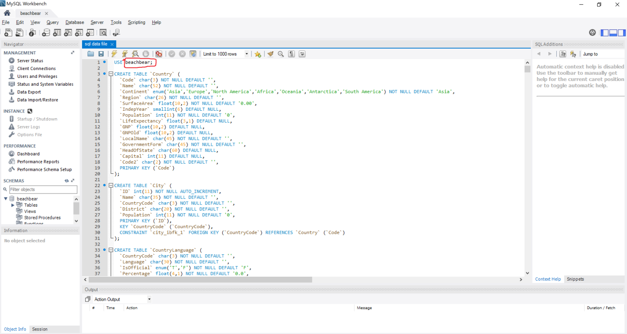

* 1. The ONLY change you need to make is where I circled in red
     1. Change this name to your username from step 5
  2. Hit “control + A” to highlight the entire file you have opened
  3. Hit the lightning button circled in red to insert the file into your database

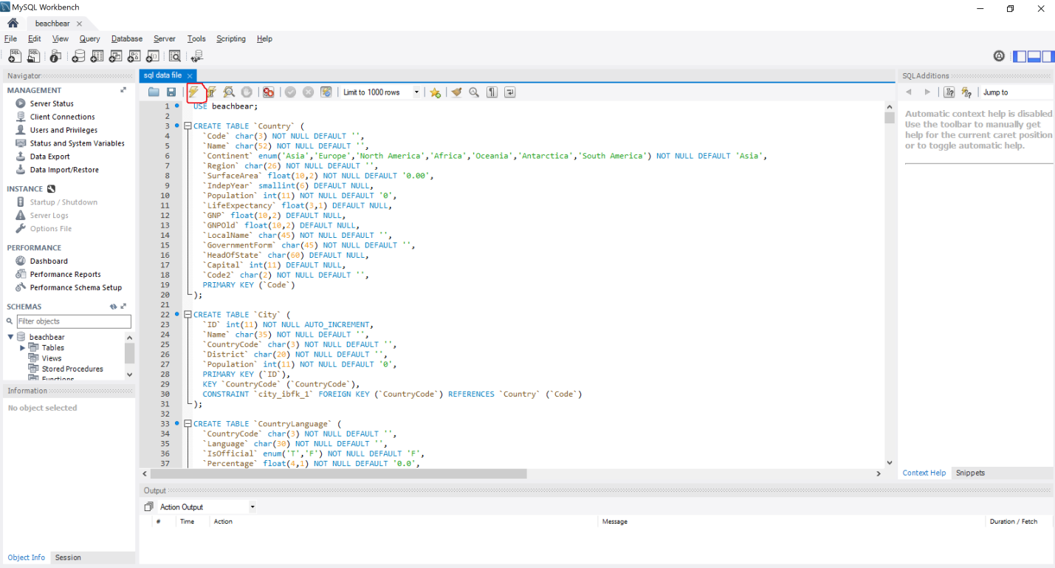

* + 1. This will take a while FYI it is 5000+ lines of code